CIT 380 – Project Management

Samuel Tsuchiya

In the beginning of the year 2019, I was hired to work at Student Records and Registration Department at Brigham Young University in Idaho after working for a little over a year for Pathway Connect. I was hired to work on building important reports for Student Records and Registration Office and other departments of the university. I started working on January 7th and I was asked to study as much as I could on how to build reports on the software called Report Builder 2002. After some time, I was asked to start studying more about Report Builder 2016 version. There were some important differences between these two software programs. The main idea of my new job was to transfer and build all the report files in the 2002 version into the 2016 version of Report Builder. I felt really inappropriate for the job but after taking several trainings on YouTube I started doing what I was asked to. The SRR office decided to hire more people to work on building these reports. By the middle of August, we were asked to transfer all those reports to Power BI Software from Microsoft and we decided that we should start applying some Project Management concepts in out team. To improve our communication, we created a group called “Student Information Unit” at SRR on Microsoft Teams in order to have a place to post our questions and information. We were able to save all our files in Teams and plan how we were going to divide our tasks and assignments.

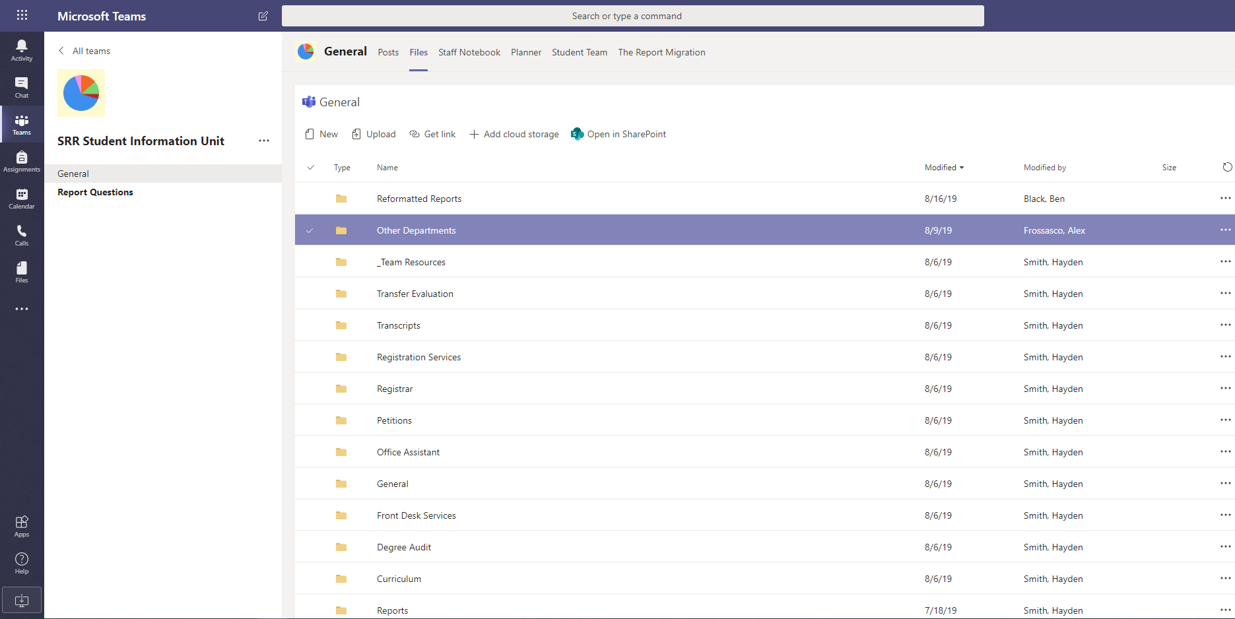

We noticed that Microsoft Teams would not be enough for all the things we needed to plan and all the things we needed to organize within our unit. We started using another software called Trello where we were able to organize our tasks, all the reports we were asked to build, our agenda and calendar. We used this track to keep track of all our assignments, we stablished our goals as a team, as a unit and as a department. We also decided to have our Unit meetings every Thursday to discuss the issues and successes of the requested reports in that week. Every meeting there is a specific person to take notes and save them in Trello. This software was a very good tool to organize our ideas and help us prioritize the tasks. We started migrating all the reports that were built in Report Builder to Power BI, and after some time we started receiving some report requests from our office and from different departments.

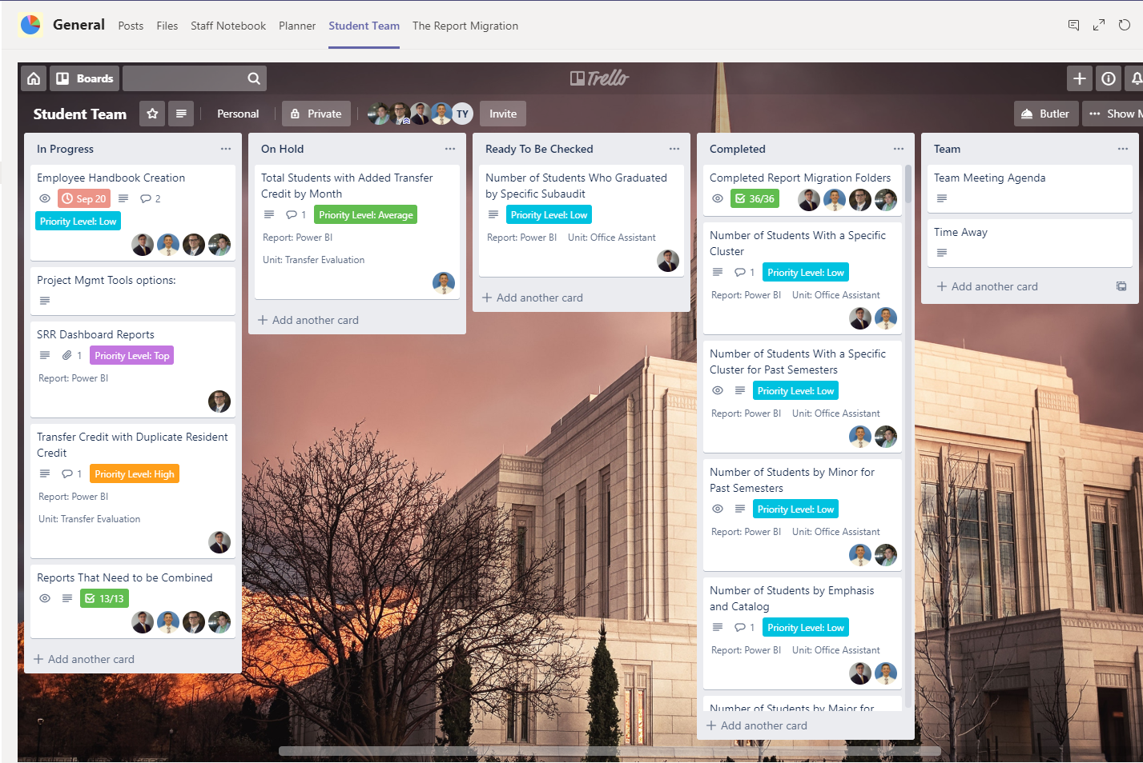

We decided to create a form in Microsoft forms to help people request a report from our unit. We received these requests and as a team we classified them according to their emergency (Low, Medium, High, Important, Urgent) in our weekly meetings. After prioritizing them, we assigned them to different members of the unit.

We also started building a Student Information Unit Handbook with all the procedures and instructions related to our job (The 4 Pillars of SRR, the Hiring Process, Standard Operating Procedures, Employee Expectations, Job Description, Work Assignments, Project Workflow, File and Document Organization and Management, Weekly Team Meetings, Professional Development, 1 on 1’s, Team Activities).

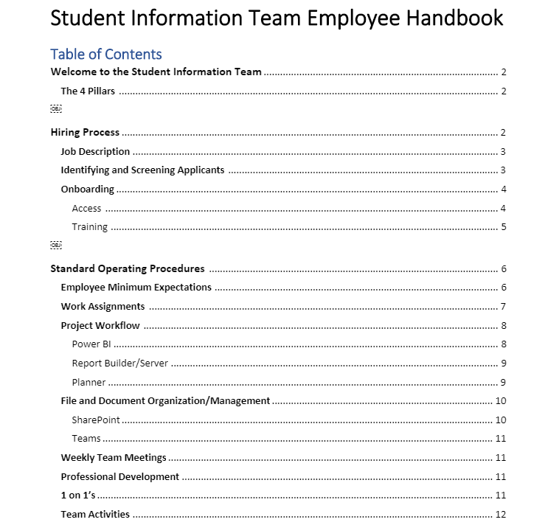

We also were able to create our main duties in our unit:

1. The creation/management of data warehouse reports and dashboards,
2. Auditing the accuracy of student records,
3. Analyzing large datasets,
4. Aiding the other SRR units with their data management

We also identified the minimum skill set for the next employees in our unit:

1. Detail-oriented and highly motivated
2. Work well on a team
3. Strong analytical / critical thinking skills
4. Professional communication / conduct
5. Quick learner
6. Ability to manage multiple projects and adjust workflow as needed
7. Ability to collect, interpret, represent, and report on quantitative data using industry-standard tools
8. Experience with the following is desired: Microsoft Excel, any database structure software (SQL, Azure, etc.), and Power BI.

We created some tutorials to help the future new employees understand all the procedures and patterns as we build reports in Power BI. We are currently working on making tutorial videos on how to make better use of Power BI tools in our daily work.

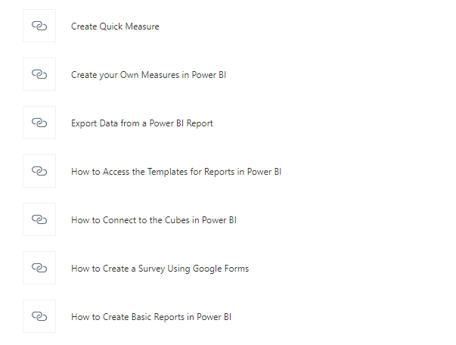

We have started working creating some Visual Job Aids to help us visualize our work processes such as creating and Updating cards in Trello, Report Request Flow, Starting a Report in Power BI, Useful DAX Code Measures, The Entities in Cubes to use with each other, etc. The picture below represents the process for creating and Updating a Card in Trello.

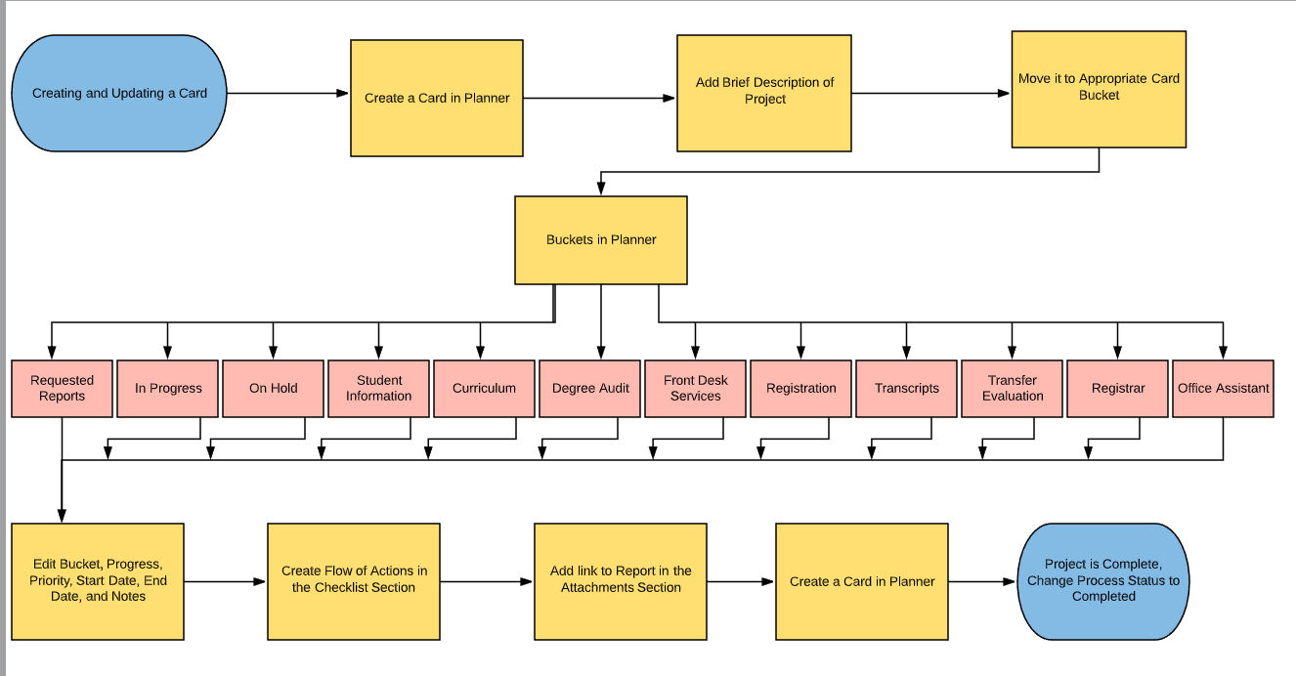

After some months using Trello Software, we decided to use the Microsoft Planner to help us manage all our reports and assignments. We transferred all the information from Trello to Planner because we felt that the layout was more efficient, and clear. We have been using it since then.

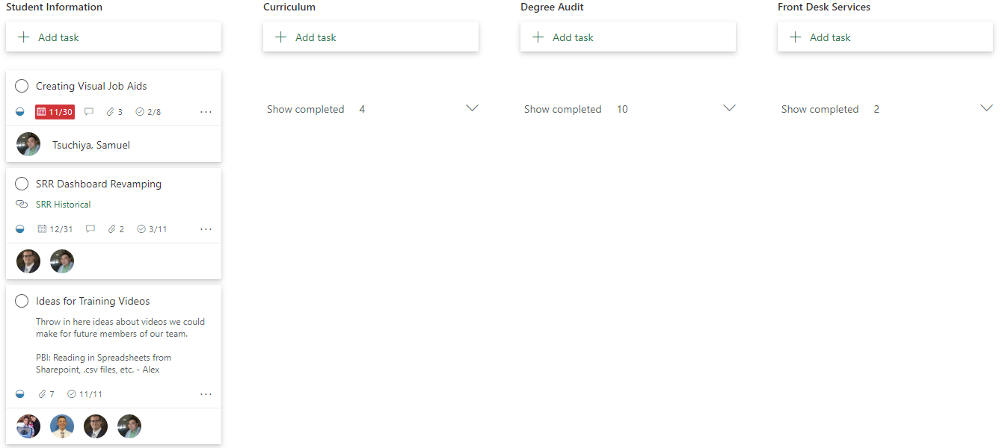

We have been working in a website from Sharepoint to help us optimize our time by having links to all the reports we have built, our agenda, calendar, Planner, Student Information Handbook. I feel we have done many things in these last three months and we are going to continue making some changes and improvements.

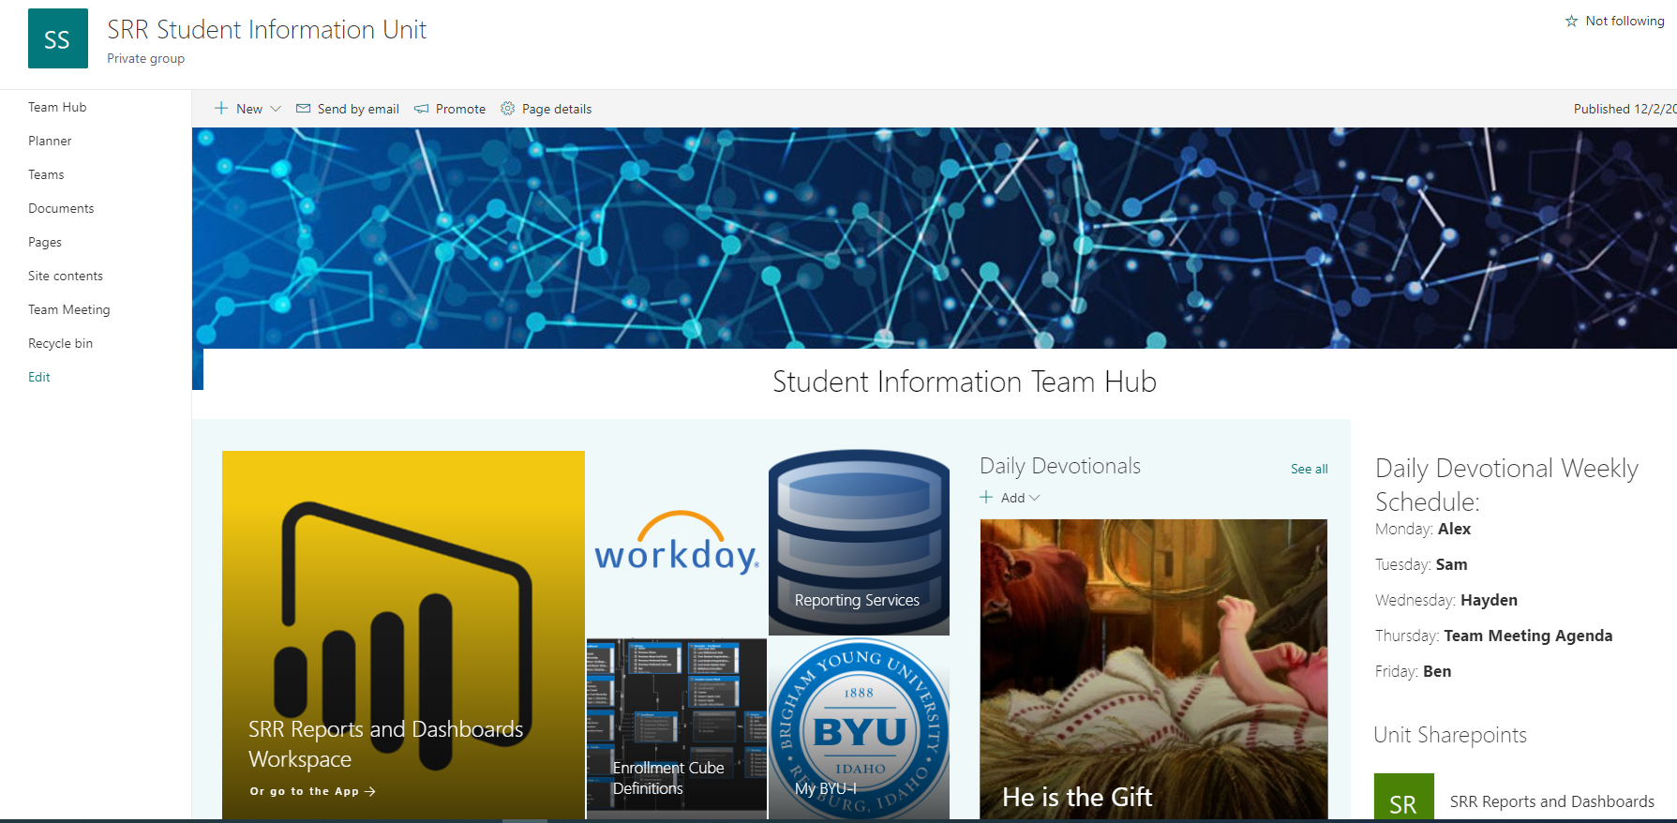

I am grateful for all these available tools to help us manage our team. SRR has hired a coordinator that focuses on managing all these tools, then the rest of the team will be more focused on the tasks and reports. I am grateful for the opportunity of working and contributing to build an unit from scratch. I was able to see these project management concepts in action.